|  |  |
| --- | --- |
| A house covered in snow  Description generated with very high confidence [9]  Hydraulic House  Hydraulic Circuit | Team 2  Fareen Lavji  Sian Smith  Reid Paxton  Christopher Canton  Thomas Da Silva  Date Submitted: April 11, 2018  Instructor: Ricardo Tabone  Peer Mentor: Narmada Samdandam  Project Report  CCDP 2100U W18 T2 |

# Executive Summary

Table of Contents

[1 Introduction 5](#_Toc511250858)

[1.1 Purpose 5](#_Toc511250859)

[1.2 Utility 5](#_Toc511250860)

[1.3 Novelty 5](#_Toc511250861)

[2 Background 5](#_Toc511250862)

[3 System Overview 6](#_Toc511250863)

[3.1 Original Design 6](#_Toc511250864)

[3.2 Updates 6](#_Toc511250865)

[4 Feature Description 7](#_Toc511250866)

[5 Challenges and Changes 8](#_Toc511250867)

[6 Conclusion 8](#_Toc511250868)

[References 9](#_Toc511250869)

[Glossary 10](#_Toc511250870)

[Appendices 11](#_Toc511250871)

[Appendix A 11](#_Toc511250872)

Figures and Tables

Nomenclature

# Introduction

## Purpose

On January 8th of 2018, Instructor Ricardo Tabone requested a project where assigned teams would work on reverse engineering or designing a new product that would serve as a benefit to the industry or layman. During Team 2’s research, it was discovered that there is no safety mechanism that houses execute for destruction and devastation during floods and hurricanes. As such, Team 2 decided to create a structure for such events called the [*Hydraulic*](#_Glossary) House.

## Utility

The way the [*Hydraulic*](#_Glossary) House works is that it uses a [*hydraulic circuit*](#_Glossary), fitted in with the [*foundation*](#_Glossary) to raise a home above the flood water’s level thereby protecting the inside from damage that the water can bring. It also uses special bearings that create additional support while the house moves in a vertical position. Furthermore, it houses a flood detection system that provides additional security.

## Novelty

This system is unique in the fact that it, as mentioned above, raises an entire home off the foundation. Not only that, but it does so proportional to the level of flood water. This is due to the [*hydraulic circuit*](#_Glossary) which creates power relative to the amount of flood water it intakes. Because the circuit of the [*hydraulics*](#_Glossary) are full of water during a flood, the house stays raised until the flood water dissipates. It serves to also be ingenious because the structure sources power from the flood water to run the system, thereby making it self [*sustainable*](#_Glossary).

# Background

It is a challenge to find safety mechanism existing for preventing heavy rains or hurricanes from flooding houses. Hurricane Maria reported a death toll of 62 while a supposed actual being 1052 [1]. These deaths are just a small glimpse of deaths reported from the 2017 Atlantic Hurricane Season that swept across the Caribbean and onto the coastal U.S. [2] and so many more that the world has seen from centuries of waterborne natural disasters. In addition, it has been reported that global [*precipitation*](#_Glossary) rates have been increasing annually by drastic amounts. When looking at it from a financial perspective, floods can cost over $5000 dollars depending on how deep the flood water is and direct flood damages in the 2014 Water Year totalled approximately $3 Billion dollars [3].

If it were possible to raise homes from disastrous floods, not only would we be reducing costs in the long run but, it would ensure ground safety and in worse events, more time for air evacuation. To achieve this goal, Team 2 designed this relatively simple system that uses a lot of old age technology that is naturally [*eco-friendly*](#_Glossary) and viable to produce as further explained.

# System Overview

## Original Design

The structure of the design was a relatively simple in that it used compressed air to push the [*pistons*](#_Glossary) of the [*hydraulics*](#_Glossary), thereby raising the home off its foundation. To keep the home intact while it raised, it needed [*Elastomeric Pad Bearings*](#_Glossary), currently used in bridges as depicted in Figure 2. These bearings support the vertical pressure and allow horizontal movements while holding the structure together by balancing all forces the house is experiencing to 0. Another feature the team intended to implement was to line the house with flood detectors that used [*capacitors*](#_Glossary). This flood detection system allowed for additional preparation in the event of a flood, including evacuation precautions.

|  |  |
| --- | --- |
| CCDP2100U_W18-A3_T2 - PowerPoint  Figure 1: Crude Hydraulic Home model [4] | **CCDP2100U_W18-A3_T2 - PowerPointFigure 2: Elastomeric Pad Bearings on Bridge** |

## Updates

The Hydraulic house now stands on 5 hydraulic [*pumps*](#_Glossary) embedded within the foundation. Each [*pump*](#_Glossary) lies at a corner of the home and the fifth lies under the centre, to provide balance. The [*pumps*](#_Glossary) serve as components of a complete [*hydraulic circuit*](#_Glossary) that lay underneath the foundation. Figure 3 shows a crude idea of the house and [*pump*](#_Glossary) structure.

[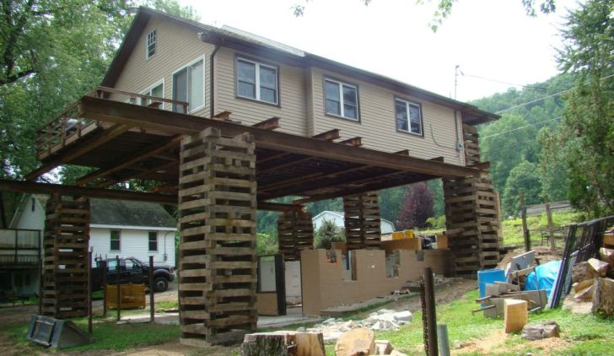](https://www.google.ca/url?sa=i&rct=j&q=&esrc=s&source=images&cd=&cad=rja&uact=8&ved=2ahUKEwiYkqn-2LPaAhUM7IMKHfGSBucQjRx6BAgAEAU&url=http://houseraising.com/2017/11/25/house-lifting-process/&psig=AOvVaw21Xg4xbHZN3J2JSz-mwx1O&ust=1523586674109701)

Figure 3: Hydraulic Home Exterior Model [5]

The location of the flood detectors has also been moved. They now line the [*reservoir*](#_Glossary) of the [*hydraulic circuit*](#_Feature_Description) depicted in Figure 4. This allows for the circuit to instantly be activated when the sensors go off. The idea of using a [*trompe*](#_Glossary) has been eliminated which can be further explained in [Section 5](#_Challenges_and_Changes).

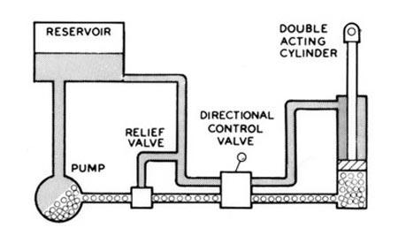

**Capacitors**

Figure 4: Hydraulic Circuit [6]

For the complete research conducted as well as a break down of components taken up by each team member, see [Table 1 in Appendix A](#_Appendix_A).

# Feature Description

As observed from [Appendix A](#_Appendix_A), the system needed to account for using the flood water to run the [*hydraulics*](#_Glossary) because chances of electricity running in the event of a flood or hurricane are low and can be quite dangerous. Creating a system that uses the floods destructive property to run the mechanism also creates a more [*sustainable*](#_Glossary) system.

## The circuit

The circuit of the system is made up of 5 components and has 2 modes when in use. It comprises of a reservoir, pump, relief valve, directional control valve and double acting cylinder. The 2 modes are [neutral](#_Neutral) and [active](#_Active). Sian Smith chose to focus on the relief valve and double acting cylinder and their functions as can be observed in [Appendix A](#_Appendix_A).

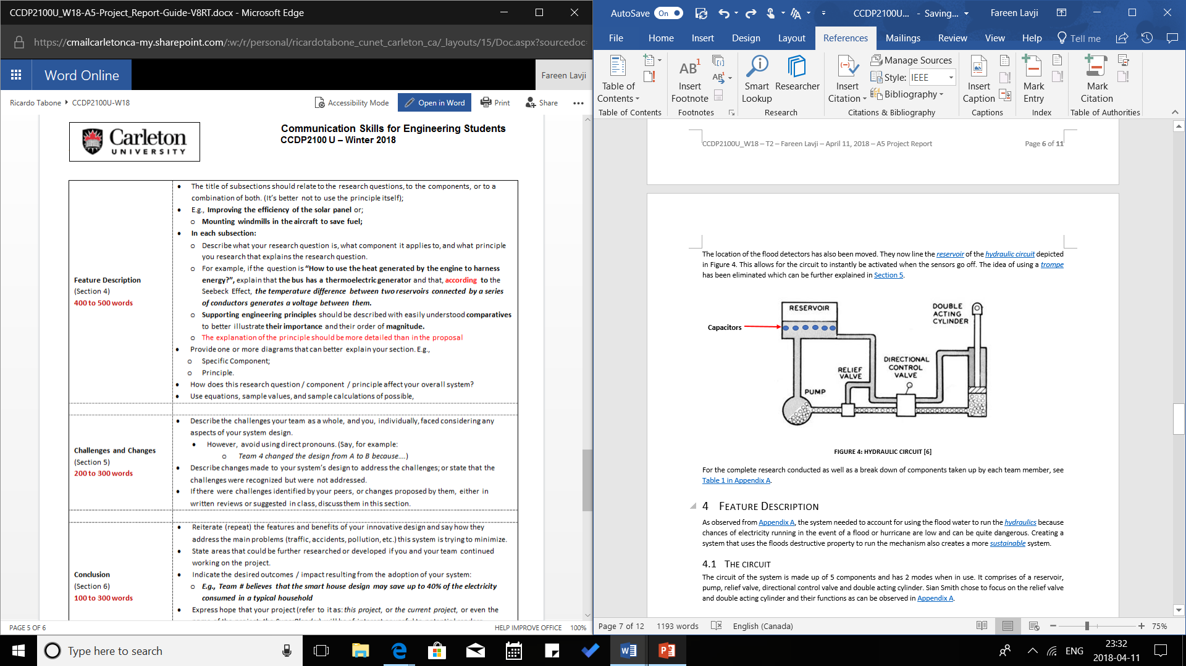

Figure 5: Hydraulic Circuit [6]

### The Reservoir

The reservoir is a tank that collects the water before it enters the circuit. It is also the component lined with the [*capacitors*](#_Glossary) that flip the switch of the relief valve to the [active mode](#_Active) of the circuit.

### The Pump

The pump is responsible for creating a steady flow of water, pumped into the circuit, thereby creating pressure within all the pipes that is responsible for pushing the double acting cylinder up. This relation can be observed through Pascal’s Law: -

[7]

The pressure created in the network of pipes is responsible for lifting the cylinder and the pressure is built up from the pump.

A close up of a clock

Description generated with high confidence

Figure : Rotary Vane Pump [8]

The pump chosen to be used is a Rotary Vane Pump which is a rotor with deep grooves along the edge that accommodate metal slabs freely allowed to move up and down in the bulbous section of the pump’s casing. The convenient aspect of this pump is that it requires low pressure to be activated. Anything as low as 1 atmospheric pressure can activate the pump. So, water flowing through can easily create suction, thereby activating the system to [neutral mode](#_Neutral).

### Directional control Valve

The directional control valve is a box of gateways that switch the circuit between its 2 modes.

## Circuit Modes

### Neutral

### Active

# Challenges and Changes

# Conclusion

# References

|  |  |
| --- | --- |
| [1] | F. Robles, "Nytimes.com," 09 December 2017. [Online]. Available: https://www.nytimes.com/interactive/2017/12/08/us/puerto-rico-hurricane-maria-death-toll.html.. [Accessed 2018 January 2018]. |
| [2] | Wikipedia, "Atlantic Hurricane Season," Wikimedia Foundations, Inc, 01 February 2018. [Online]. Available: https://en.wikipedia.org/wiki/2017\_Atlantic\_hurricane\_season. [Accessed 01 February 2018]. |
| [3] | National Weather Services, 2014. [Online]. Available: http://www.nws.noaa.gov/hic/summaries/WY2014.pdf.. [Accessed 11 April 2018]. |
| [4] | CCDP2100U\_W18\_T2, "Hydraulic House," Ottawa, 2018. |
| [5] | CCDP2100U\_W18\_T2, "Hydraulic Home," Ottawa, 2018. |
| [6] | Cross, "Basic Hydraulic Theory," Cross Manufacturing Inc, [Online]. Available: https://crossmfg.com/resources/technical-and-terminology/basic-hydraulic-theory. [Accessed 1 April 2018]. |
| [7] | D. Halliday, R. Resnick and J. Walker, Fundamentals of Physics, Wiley, 2013. |
| [8] | E. Lewis, "Sliding Vane Pump Information," GM Pumps, 24 January 2014. [Online]. Available: www.gmpumpsa.com/positive-displacement-pumps/sliding-vane-pumps/sliding-vane-pump-information/. [Accessed 1 April 2018]. |
| [9] | D. Rodkin, "National Trust wants to Give Farnsworth House a lift," Chicago Business, 10 November 2015. [Online]. Available: www.chicagobusiness.com/realestate/20151110/CRED0701/151119999/national-trust-wants-to-give-farnsworth-house-a-lift. [Accessed 11 April 2018]. |

# Glossary

|  |  |
| --- | --- |
| Capacitor | A device consisting of at least one pair of conductors separated by an insulator that store stores an electric charge |
| Eco-Friendly |  |
| Elastomeric Pad Bearing | A bearing commonly used in bridges |
| Foundation | The lowest load-bearing part of a building, typically below ground level |
| Hydraulic | Mechanical system that uses pressurized liquids in pipes to move objects |
| Piston | A disk fitted closely with a tube that can move up and down against a liquid or gas |
| Sustainable | A system that can maintain at specified levels |
|  |  |
|  |  |
|  |  |

# Appendices

## Appendix A

Table 1: Research Table

|  |  |  |  |
| --- | --- | --- | --- |
| **Team Member** | **Research Question** | **Component** | **Principle** |
| Chris Canton | Flood Detection Mechanism | Flood Detector  (Capacitor) | * Ohm's law   Archimedes' principle |
| Thomas Da Silva | How to keep the structure of the house intact while the hydraulics are moving it | House Structure | Newton's Second Law |
| FareenLavji | How to use the flood water to run the hydraulics. | Hydraulic Circuit  (Fuel Support) | * Bernoulli's Principle * Venturi Effect * Pascal's Law |
| Paxton Reid | Ways to accommodate for the effects of the floodwater on soil | Foundation and Soil | Darcy's Law |
| Sian Smith | How to use hydraulics to lift the house | Hydraulic Pumps | Pascal's Law |